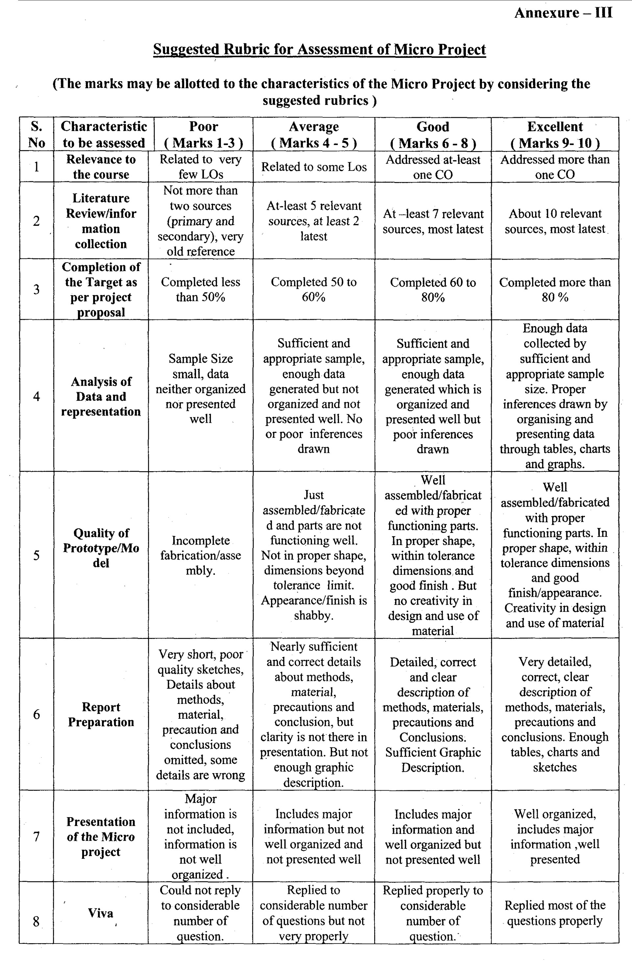

# Annexure- IV

**Micro Project Evaluation Sheet**

## Name of Student: Deore Samarthya Ravindra

**Title of the Micro-Project:** Sources and Effect of Common Air Pollutants

**Course Outcomes Achieved:**

1. Develop Public awareness about environment
2. Conserve Ecosystem and Biodiversity
3. Apply techniques to reduce Environmental Pollution
4. Manage social issues and Environmental Ethics as lifelong learning

|  |  |  |  |  |  |  |
| --- | --- | --- | --- | --- | --- | --- |
| Sr.  No. | Characteristic to be assessed | Poor (Marks 1 - 3) | Average (Marks 4 - 5) | Good (Marks 6 - 8) | Excellent (Marks 9- 10) | Sub Total |
| (A) Process and Product Assessment (Convert above total marks out of 6 Marks) | | | | | | |
| 1 | Relevance to the course |  |  |  |  |  |
| 2 | Literature Review/information |  |  |  |  |
| 3 | Completion of the Target as  per project proposal |  |  |  |  |
| 4 | Analysis of Data and representation |  |  |  |  |
| 5 | Quality of Prototype/Model |  |  |  |  |
| 6 | Report Preparation |  |  |  |  |
| (B) Individual Presentation / Viva (Convert above total marks out of 4 Marks) | | | | | | |
| 7 | Presentation |  |  |  |  |  |
| 8 | Viva |  |  |  |  |

|  |  |  |
| --- | --- | --- |
| (A) Process and Product Assessment (6 marks) | (B) Individual Presentation/Viva (4 marks) | Total Marks (10 marks) |
|  |  |  |

**Comments/Suggestions about team work/leadership/inter-personal communication (if any)**

## ( Prof. S. S. Shah )

Lecturer in Industrial Electronics